.

Design Document for PREQ806, REQ3655

Status: | Issued
Version: | 1.0
Author: | Simon Conway
Reviewers: | Husien Hong, Richard Maynard, Alexander Dimitrov, Stephen Mansfield
Team/Department : | System Libraries/Core Development

Contents
1 Introduction 3
1.1 Purpose and Scope 3
2 Design Overview 3
3 Detailed Design 3
3.1 Ecom 3
3.1.1 Discovery.cpp 3
3.1.2 Registrar.cpp 3
3.1.3 RegistryData.cpp 3
3.1.4 Design Considerations 4
3.1.5 Dependencies 4
3.1.6 Testing 4
3.2 Bafl 5
3.2.1 CResourceArchive 6
3.2.2 CResourceFile 7
3.2.3 RResourceFileImpl 7
3.2.4 Design Considerations 7
3.2.5 Testing 7
4 Further Information 7
4.1 References 7
4.2 Open Issues 7
Appendix A - Ecom Start up Performance Investigation 8
A.1 Ecom Start up Performance Investigation (PREQ806) 8
A.1.1 Purpose 8
A.1.2 Procedure 8
A.1.3 Equipment 9
A.1.4 Builds Used 9
A.1.5 Results 9
A.1.6 Breakdown of “Total Scan” Times 9
A.1.7 Summary 11
A.1.8 Risks 12

Introduction

Purpose and Scope
This document describes the changes required to the ECOM and BAFL components in order to satisfy PREQ806 and in particular REQ3655. This PREQ is required for 9.1 (Mike).
The target audience that this document is intended includes the TA and engineers within System Libraries, Tools and Test Engineering. Also the Project Manager responsible for the PREQ delivery.

Design Overview
PREQ806 requires that Static Plugin Information (SPI) for RO media should be generated at ROM build time rather than scanning for plugin files during ecom start-up at device boot up.
Currently, at both first and subsequent boots ecom scans the Z drive for plugin files and either creates or updates the Ecom.ROM.dat file stored on the C drive respectively.
The changes outlined in this section was dictated by the results of performance testing. This testing determined what phases were involved in ecom start-up and provided a breakdown of the time taken to scan for plugin. See Appendix A -.

Detailed Design

Ecom
The following sections outline the detailed design for ecom.

Discovery.cpp
- Remove direct references to Z drive and use alternative indicator (BaflUtils::DriveIsReadOnlyInternal()) to determine when a drive is RO media.
- When a drive is RO media read SPI file from \private\10009D8F and populate the registry from this. Do not scan \resource\plugins for RSC plugins.
- If the SPI file does not exist scan \resource\plugins for Secure plugins and populate the registry.
- As RO media may be composite read SPI file for each type. i.e. ecom01.spi, ecom02.spi etc. Its possible that SPI for each type of RO media may be merged into a single SPI file.
- To read the SPI file make use of the new BAFL Resource File API’s.
- Scan \System\Libs\Plugins for Legacy plugins and populate the registry.
- Optimise code that determines the DLL path from the RSC file.
- Add call to BaflUtils::NearestLanguageFile() for the ecom.spi file.

Registrar.cpp
- Modify CRegistrar::ParseRegistrationDataL and CRegistrar::ParseL to allow references to TDes8 (RSC data within SPI file) to be passed in addition to the path for a plugin. Possibly new overloads required.
- Make use of new BAFL api’s to read RSC data from SPI file.

RegistryData.cpp
- Internalize all c:\private\10009D8F\Ecom.ROM[drive no].dat files. These will only exist if during previous boot up they were created because no SPI file existed or because some plugins were discovered by DLL.
- Only persist/externalize the registry for the RO media if no SPI exists or if plugins were discovered by DLL. Persisted data to be stored in c:\private\10009D8F\Ecom.ROM[drive no].dat
- Remove direct references to Z drive and use alternative indicator (BaflUtils::DriveIsReadOnlyInternal()) to determine when a drive is RO media.

Design Considerations
- The ecom changes will be made to the ecom\ongoing branch within MCL. This branch is used for 9.0 (Yankee) onwards.
- The changes for 9.1 (Mike) include a fallback mechanism whereby if no SPI file exists then plugin files will be scanned. This fallback mechanism will be used for 9.0 builds to ensure behaviour remains the same.
- All changes made to ecom must allow either single mode (RSC discovery only) or dual mode (DLL and RSC discovery) operation depending on which mode is configured.
- Ecom will either discover plugins from an SPI file or by scanning (single mode or dual mode). Never both.
- All changes made to ecom must be within the PlatSec framework implemented in 9.0.
- Addition and removal of plugins are triggered by DllDirNotifier and RscDirNotifier. When any change occurs all plugins for all drive units are rediscovered. These notifiers also detect the addition and removal of drives also causing all plugins for all drive units to be rediscovered. Therefore, for this PREQ, no additional code is required for discovery of RO drives should their addition or removal be possible.
- The PlatSec SID check for discovery from ecom.spi will be bypassed for release builds only. This is because the ecom.spi file exists on RO media which is deemed secure.
- BaflUtils::NearestLanguageFile() will be called for the ecom.spi file.

Dependencies
- Ecom is dependent on the new API’s provided by Bafl to read the RSC data from the SPI file.
- The SPI files format must be agreed and be made available in RO builds.
- SPI files are usually only created during buildrom.
- A standalone spitool will be available to allow SPI testing to take place on the emulator. This tool will be invoked for emulator builds only, at the end of compilation and but before the test run begins.

Testing
The implementation of this PREQ does not change the way in which clients will use ecom. Clients will use ecom in the same way as it is used today.
The following automatic tests will be added to test SPI functionality:
t_discoverer: ProcessSpiEntryTestL() SYSLIB-ECOM-CT-0091
ValidateSpiEntryTestL() SYSLIB-ECOM-CT-0092
ValidateSpiPluginsTestL() SYSLIB-ECOM-CT-0093
t_registrar: ParseSpiTestL() SYSLIB-ECOM-CT-0089
ParseSpiRegistrationDataTestL() SYSLIB-ECOM-CT-0090
t_registrydata SPIExistenceTestL() SYSLIB-ECOM-CT-0088

Bafl
One new class, CResourceArchiveIter, is required in the bafl component to provide a set of high level API’s to read the contents of the new SPI file.
Additionally, the existing classes CResourceFile and RResourceFileImpl will need updating to read the resources.
The following class and sequence diagrams show how this design is intended to be used to read SPI files.

Class Diagram
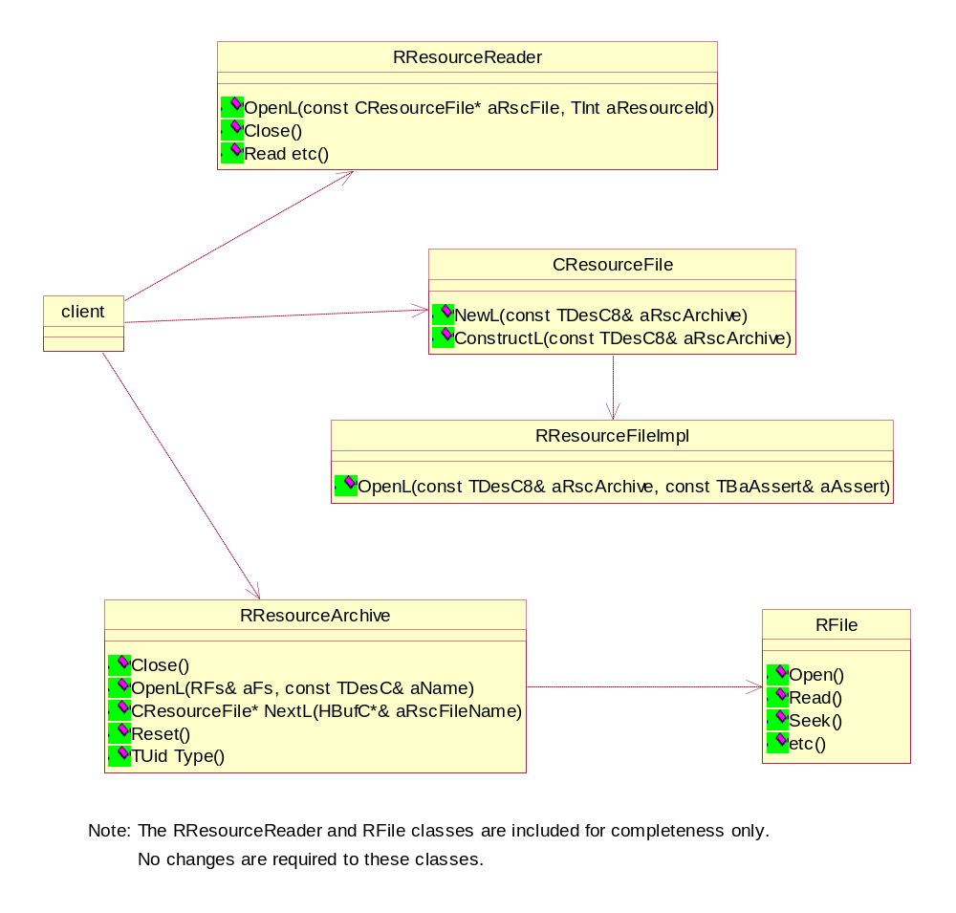

Sequence Diagram
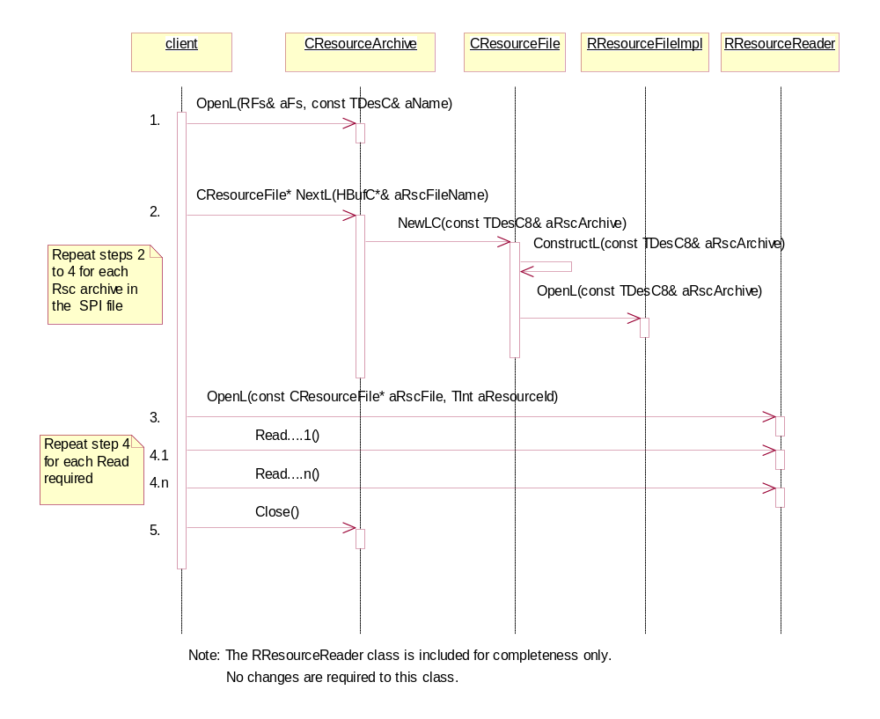

CResourceArchive
- This is a new class that is responsible for opening and extracting RSC archives and their associated names from the given SPI file.
- Type() can be used to retrieve the file type uid.
- NextL() can be used to retrieve a pointer to CResourceFile for each RSC archive within the SPI file and also the RSC archive name. NextL() will return a null pointer when no more RSC archives exist.
- Reset() will reset the object to its initialised state, so that any subsequent call to NextL() retrieves the first archive.
- An important feature of this class is that it must be possible for the RSC archives to be extracted from the SPI file with the SPI file being opened only once. The SPI file must not be continuously opened and closed during RSC archive extraction.
- Each RSC archive to be extracted must only be read from the SPI file when required.
- This class will use RFile to open, close and extract data from the named SPI file.

CResourceFile
A new NewL() function and its corresponding ConstructL() function must be added to this class that allows an instance to be created from an RSC archive rather than from an RSC file name. The behaviour of the class will remain unchanged.

RResourceFileImpl
A new OpenL() function must be added to this class that allows a resource to be opened from an RSC archive rather than from an RSC file name. The behaviour of the class will remain unchanged.

Design Considerations
- There are no configuration issues as API’s are being added only. The highest risk is to RResourceFileImpl as some minor restructuring of its code will be required.
- There are no compatibility breaks due to changes to CResourceFile as 2 new functions are being added only.
- The size of RResourceFileImpl must not be changed as the size of this class effects the size of RResourceFile and CResourceFile. To ensure that there are no compatibility breaks due to changes to RResourceFileImpl any new data members for this class must be added using the TExtra.

Testing
The following automatic tests will be added to test new BAFL functionality:

Loading/Reading SPI file from XIP media SYSLIB-ECOM-CT-0094
Loading/Reading SPI file from Non-XIP media SYSLIB-ECOM-CT-0094
Testing functionality of the Reset() function SYSLIB-ECOM-CT-0094
Testing comparison of spi and rsc read CResourceFiles SYSLIB-ECOM-CT-0094
Testing opening a non-spi file SYSLIB-ECOM-CT-0094
Tests Baflutils::TestDriveIsReadOnlyInternal SYSLIB-ECOM-CT-0095

Further Information

References
No. | Document Reference | Description
[R1] | V:\\Dev\GT\GT0219\ | Project Folder
[R2] | V:\Dev\GT\GT 0219\Requirements | Functional Description
[R3] | V:\Dev\GT\GT 0219\Test\SGL.GT0219.201 V1.0 Mike System Libraries Test Plan.doc | Test Plan

Open Issues
DEF053116 - RSC Plugins should take precedance during ecom dual mode discovery – New Defect
DEF053121 - Calls to nearest language file cause possible security threat - Awaiting Investigation
DEF053124 - t_resolver and t_suicide tests fail during ONB - Fix Verified
- Ecom Start up Performance Investigation
25th October 2004
  - Ecom Start up Performance Investigation (PREQ806)

Author: Simon Conway
Dept: System Libraries
Component: ecom
    - Purpose
To determine whether the use of ROM static plugin information generated at build time instead of scanning the ROM at runtime would be likely to give a 5% improvement in ecom start-up time.

See PREQ806: eliminate scanning for plug-ins on start-up
    - Procedure
Each phase of ecom start-up was identified:

Internalize .dat – building of Registry from ecom.ROM.dat saved to RW media in previous start-up
Binary Scan – discovery of plugins by DLL files
Resource Scan – discovery of plugins by resource files
Validate – checks registry DLL’s against DLL on each drive unit (uses RLibrary::GetInfo())
Persist – writing of registry to create .dat files

TUint t1 = User::FastCounter() statements were added to determine how long each phase of start-up took.

Ecom code was modified to simulate both a cold start and a warm start in a single run of execution.

cold start – no ecom.ROM.dat file exists therefore nothing to do during internalisation phase. ecom.ROM.dat created during persist phase. Occurs first time phone turned on or corrupt data detected.

warm start – ecom.ROM.dat exists therefore registry is updated during internalisation phase. Occurs second and subsequent times phone turned on.

Plugins only existed on the Z drive unit for this test.

Results captured for image loaded both to RAM and to NOR.

NAND results have not been captured at this time due to setup and configuration problems. There is no supported Techview NAND image.
    - Equipment
H2 board - ENG56849
    - Builds Used
Release 03378_Symbian_OS_v9.0
Release 03396_Symbian_OS_v9.0

Code taken from …/MCL/ecom/ongoing...

The ongoing branch includes code so that ecom works in dual mode. i.e. It discovers plugins from both binary (insecure) and resource plugin (secure) files.
    - Results
All times are in mSeconds
03378_Symbian_OS_v9.0
44 dll, 89 rsc, 152 interfaces, 216 implementations

Phase |  | RAM |  | NOR
 |  | 1st Run | 2nd Run | 1st Run | 2nd Run
Cold start | Internalize .dat | 5 | 6 | 12 | 12
 | Binary Scan | 448 | 449 | 784 | 784
 | Resource Scan | 2353 | 2358 | 4921 | 4921
 | Total Scan | 2850 | 2851 | 5796 | 5796
 | Validate | 387 | 386 | 868 | 868
 | Persist | 57 | 57 | 114 | 114
 | Total Time | 3361 | 3361 | 6886 | 6886
Warm start | Internalize .dat | 400 | 400 | 865 | 865
 | Binary Scan | 450 | 450 | 782 | 783
 | Resource Scan | 2192 | 2192 | 4494 | 4494
 | Total Scan | 2688 | 2688 | 5367 | 5366
 | Validate | 264 | 264 | 599 | 599
 | Persist | 60 | 60 | 112 | 112
 | Total Time | 3482 | 3482 | 7049 | 7049
Table 1

Note: The Binary Scan and Resource Scan times are included in the Total Scan time

    - Breakdown of “Total Scan” Times

This section contains times for the most time consuming stages of the scan.

There is minimal difference between the cold start and warm start scan times. The difference can be attributed to the registry being written to memory in the cold start but not in the warm start. Because of these minimal differences only warm start figures are provided in the following tables.

All times are in mSeconds.

Definitions:

Read and decode of RSC files
- Creation of objects to hold info on dll, interfaces and implementation

Open/Close Files
- Open and close of RSC files
- Does not include reading of data from file

Plugin Filename Retrieval
- Retrieval of list of plugins that exist in the plugin dirs.

Determine DLL path/filenames from RSC
- Constructs DLL path/filename from RSC file

Call to BaflUtils::NearestLanguageFile
- Gets nearest RSC file prior to internalize

Verify SIDL Plugin (RSC only)
- Uses RLibrary::GetInfo() to determine if the RSC matches the DLL.
- Gets BaflUtils::NearestLanguageFile prior to check for match

03378_Symbian_OS_v9.0

13th October 2004
44 dll, 89 rsc, 152 interfaces, 216 implementations

Scan Phase | RAM | NOR
Read and decode of RSC files | 126 | 183
Open/Close Files | 352 | 802
Plugin Filename Retrieval | 69 | 82
Determine DLL path/filenames from RSC | 1021 | 2084
Call to BaflUtils::NearestLanguageFile | 532 | 931
Verify SIDL Plugin (RSC only) | 1157 | 2136
Total | 3257 | 6218
Table 2

03396_Symbian_OS_v9.0

21st October 2004
0 dll, 140 rsc, 165 interfaces, 229 implementations

Scan Phase | RAM | NOR
Read and decode of RSC files | 129 | 183
Open/Close Files | 387 | 864
Plugin Filename Retrieval | 111 | 127
Determine DLL path/filenames from RSC | 1400 | 2520
Call to BaflUtils::NearestLanguageFile | 560 | 980
Verify SIDL Plugin (RSC only) | 1960 | 3360
Total | 4547 | 8034
Table 3

Internalize .dat figures for this build: RAM – 417mSec, NOR – 887mSec
    - Summary

- Two ideas were put forward for the design of the SPI file.

SPI Design Idea 1 – SPI file as a list of RSC file names only
From table 3 this design would reduce the scan time by 127mSec (less the time to open and close the SPI file). This is the Plugin Filename Retrieval time for NOR.

SPI Design Idea 2 – SPI file as a list of RSC file names plus the RSC file content
From table 3 this design would reduce the scan time by 991mSec (less the time to open and close the SPI file). This is made up of the Plugin Filename Retrieval and the Open/Close Files time for NOR.

- Localisation of the RSC files for RO media would be done at ROM build time. Therefore the call to BaflUtils::NearestLanguageFile would not be necessary. This would reduce the scan time by 980mSec for NOR.

- By not creating the .dat file for RO media, and, always reading from the SPI file instead would increase security by reducing the opportunity for .dat file corruption. The internalization from .dat for NOR is 887mSec. This would be replaced with the Read and Decode of RSC files phase from table 3 which is 183mSec for NOR.

- There is the possibility of removing the “Verify SIDL Plugin” scan phase for RO media as both the dll’s and RSC are secure. From table 3 this would save 3360 mSec for NOR. SMG are currently looking at this idea.
    - Risks

- All figures in the Summary are quoted for NOR only. It is understood that NAND flash testing will result in figures that are higher than those quoted in the Results section.
- No testing has been done with NAND flash as yet due to setup and configuration problems. There is no supported Techview NAND image. It is hoped that NAND flash testing will be possible at design completion.
- Impact of post manufacture installation of plugins on RW media not characterised and would contribute to total performance and is outside the scope of PREQ806.

